Name:__________________________________________ Due Date:________________________

Regents Review #4: Cellular Transport and Diffusion Through a Membrane State Lab

The Big Ideas:

- Each cell is covered by a membrane that performs a number of important functions for the cell. These include: separation from its outside environment, controlling which molecules enter and leave the cell, and recognition of chemical signals. The processes of diffusion and active transport are important in the movement of materials in and out of cells.
- Many organic and inorganic substances dissolved in cells allow necessary chemical reactions to take place in order to maintain life. Large organic food molecules such as proteins and starches must initially be broken down (digested to amino acids and simple sugars respectively), in order to enter cells. Once nutrients enter a cell, the cell will use them as building blocks in the synthesis of compounds necessary for life.

State Lab Review:

Important Terms

Diffusion Selectively permeable Indicators Dialysis tubing
Starch Glucose
Starch indicator Glucose indicator
Controls Cytoplasm
Cell membrane Cell wall
Osmosis Wet mount
Cover slip
Key Points Part I
- Molecules tend to move from high to low concentration without the use of energy (diffusion).
- Membranes may allow some molecules to pass through while not allowing others (selectively permeable).
- Indicators are chemicals that change color in the presence of certain kinds of molecules.

Procedure Part I
- A model cell is made using a plastic membrane (dialysis tubing) containing starch and glucose. The bag is sealed with string.
- Starch indicator (iodine) is placed in solution outside the ‘cell’.
- Because of the differences in concentration, starch indicator diffuses in and glucose diffuses out. Starch ‘wants’ to diffuse out, but cannot because the molecule is too large to pass through the membrane.
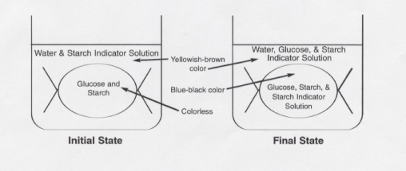

- Starch (milky white) + starch indicator (brown) = blue-black color
- The inside of the bag turns blue-black while the outside stays brown, proving that indicator went in, but starch did not leave.
- Glucose indicator (blue) + glucose (clear) + HEAT = green, brown, red, or orange
- Testing the fluid outside the ‘cell’ shows glucose has diffused out of the cell. This is tested by placing fluid from outside into a test tube, adding indicator solution, and heating the mixture.
- You may prove that #6 is true by testing (heating) indicator alone and also testing indicator + starch. Both of these controls result in a blue color (no change).

Analysis Part I
- Glucose and starch indicator may pass through the membrane. Starch may not. This is because starch is a much larger molecule than glucose or starch indicator.
- This shows the importance of breaking down large molecules inside the digestive system in order for nutrients to enter the bloodstream.

Key Points Part II
- Basic parts of the cell that are easily seen under the microscope are the cytoplasm, cell membrane, and cell wall (in plants).
- Molecules tend to move from high to low concentration without the use of energy (diffusion).
- Diffusion of water molecules is particularly important and has the special name of osmosis.
- The balance of water molecules inside and outside the cell is extremely important for the survival of all organisms, including humans.

Procedure Part II
- Make a wet mount slide of a thin section of red onion cells. The cells are taken from the outer ‘skin’ of the onion bulb and a small piece is placed in a drop of water on a microscope slide. A cover slip is placed on top by touching it to the water at an angle, and then carefully placing it on the specimen, trying not to get air bubbles underneath.
- The cells are examined under the light (compound) microscope. You should be able to identify the cytoplasm, cell membrane, and cell wall.
- It is important to see that the cell membrane and cytoplasm completely fill the space within the cell wall.

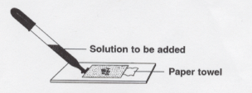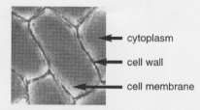

- Place a 10% salt solution under the cover slip. This is done by putting a drop of salt solution next to one edge of the cover slip, then absorbing water from the opposite side of the slip using a paper towel.
- Observe the cells in the salt solution. It is important to see that the cytoplasm and cell membrane have shriveled up inside the cell wall. This is due to water molecules leaving the cell and entering the salty (low water) solution.
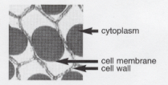

- Place distilled water under the cover slip using the technique described in #4 above.
- Observe the cells in distilled water. It is important to see that the cytoplasm and cell membrane have swollen back to fill the entire space available within the cell wall.
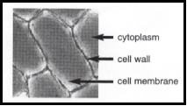

Analysis Part II
- Cells placed in very salty solutions will lose water, causing them to collapse and possibly lose the ability to complete life functions.
- Cells placed in very watery solutions will tend to gain water, which causes them to swell and might cause them to burst/break open, destroying the cell. Note that this did not happen in the plant cells because the cell wall prevents the cell membrane from easily expanding.
- Freshwater creatures, particularly single-celled organisms, must cope with too much water entering the cells. Saltwater organisms tend to have the opposite problem and must try to reclaim lost water.

