Name:__________________________________________ Due Date:________________________

Regents Review: Enzymes

The Big Ideas:

- Biochemical processes, both breakdown and synthesis, are made possible by a large set of biological catalysts called enzymes. Enzymes can affect the rates of chemical change.
- The rate at which enzymes work can be influenced by internal environmental factors such as pH and temperature.
- Enzymes and other molecules, such as hormones, receptor molecules, and antibodies, have specific shapes that influence both how they function and how they interact with other molecules.

Important Facts:

- Metabolism is the sum of all the chemical reactions that occur within the cells of an organism. Enzymes affect the rates of chemical reactions within cells. They are biological catalysts.
- Enzymes can catalyze both synthesis (building) and hydrolysis (breakdown) reactions.
- All enzymes are proteins and are therefore made up of amino acids.
- The shape of enzymes (like all proteins) is important, and determines the substrate (substance) that it can work on. Enzymes and substrates must fit together in order for the reaction to be catalyzed (“lock and key model”). The active site is the area of the enzyme where the substrate fits.
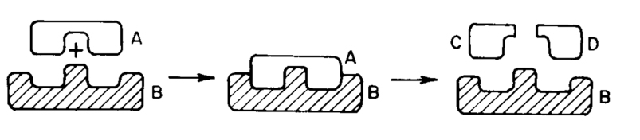

- Enzymes work best at specific temperature and pH conditions. High temperatures will cause enzymes to denature (lose their shape) and stop functioning. This is why high fevers are dangerous. Changes in pH may also cause enzymes to denature and stop functioning.
- Increasing the amount of substrate increases the rate of reaction, but only until a certain point. At some substrate concentration, the enzymes are working at their maximum rate.

